**Experiment 4:**

**1. Aim:** **RULES OF UNICAST AND MULTICAST COMMUNICATION USING PACKET TRACER SOFTWAR**

**2. Apparatus (Software):**

* Command Prompt
* Packet Tracer

**3. Procedure:**

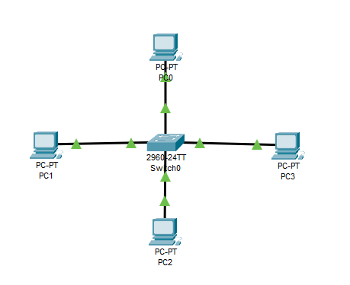**A. Unicast Communication:**

1. **Set Up the Network:**
   * Open Packet Tracer and create a new project.
   * Drag and drop two or more devices (e.g., PCs, switches, routers) onto the workspace.
   * Connect the devices using appropriate cables (Copper Straight-Through or Copper Cross-Over).
   * Configure IP addresses for each device in the same subnet.
2. **Configure IP Addresses:**
   * 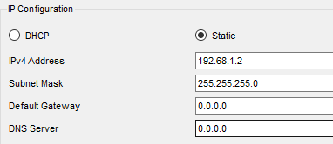Click on each device (e.g., PC1) and go to the "Desktop" tab.
   * Open the "IP Configuration" option and assign an IP address and subnet mask. For example, assign PC1 the IP address 192.168.1.1 with a subnet mask of 255.255.255.0.
   * Repeat this for the other devices with different IP addresses in the same subnet (e.g., PC2: 192.168.1.2).
3. **Verify Connectivity:**
   * 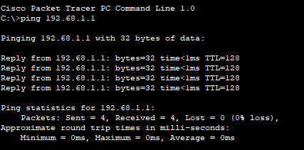Open the Command Prompt on one of the PCs.
   * Use the ping command to verify connectivity to the other device(s). For example, type ping 192.168.1.2 from PC1 to check connectivity with PC2.
   * Observe the responses to confirm that unicast communication is working.

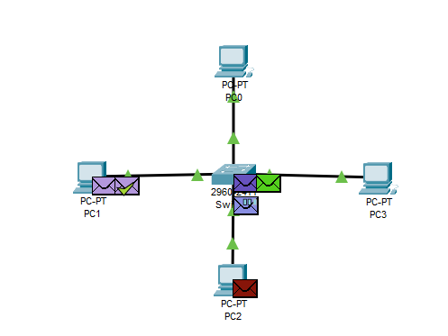

1. **Capture and Analyze Traffic:**
   * Use the "Simulation" mode in Packet Tracer to capture and analyze the packets being sent between the devices.
   * Observe that in unicast communication, packets are sent from one device directly to another device's IP address.

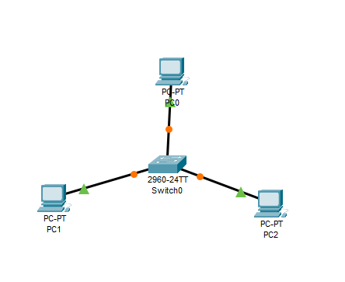**B. Multicast Communication:**

1. **Set Up the Network:**
   * Follow the same steps as in the Unicast section to set up a basic network.
   * In addition to PCs, include at least one multicast-capable device or configure the router for multicast routing (e.g., enabling IGMP).
2. 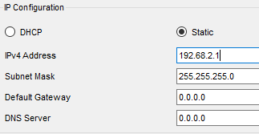**Configure Multicast Group:**
   * Assign multicast addresses to the devices. Multicast addresses typically range from 192.68.2.1 to 255.255.255.255
   * For example, configure PC1 to join a multicast group using the address 192.68.2.1

**Simulate Multicast Traffic:**

* + On one of the devices, open a Command Prompt and use tools like ping or tracert to send data to the multicast address (e.g., ping 192.68.2.1).
  + Alternatively, use Packet Tracer’s built-in tools to simulate multicast communication.

1. **Capture and Analyze Multicast Traffic:**
   * 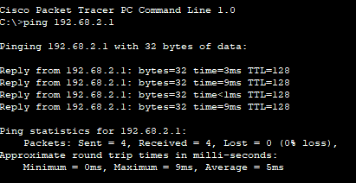Switch to the "Simulation" mode in Packet Tracer.
   * Observe that multicast packets are sent from one source to multiple destinations that are part of the multicast group.
   * Analyze the packet flow to see how multicast traffic differs from unicast, as it only reaches devices subscribed to the multicast group.
2. 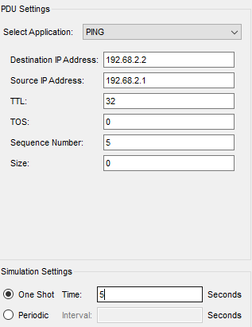**Verify Multicast Communication:**
   * Ensure that the devices subscribed to the multicast group receive the packets, while others do not.
   * This verifies the proper functioning of multicast communication in the network.

**4. Observation and Conclusion:**

* **Unicast Communication:** Packets are sent directly from one device to another specific device in the network.
* **Multicast Communication:** Packets are sent from one source to multiple destinations that have joined a specific multicast group.

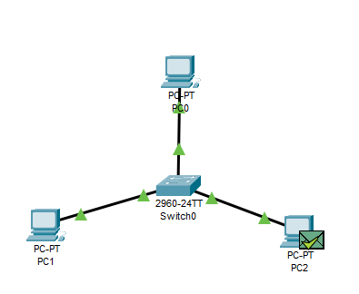Through this experiment, you should be able to demonstrate the difference between unicast and multicast communication and understand how these types of communication work within a network using Packet Tracer.